JAVA 8

- Released on March 18, 2014, by Oracle
- Support for functional programming with Lambda expressions and functional interfaces.
- Introduction of the Stream API for efficient data processing.
- A new Date and Time API for better handling of time and date operations.
- Default and static methods in interfaces for greater flexibility.

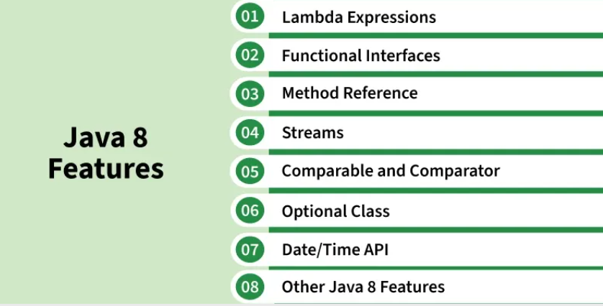

- Lambda Expressions:

The biggest feature. Before Java 8, to pass behavior around, you needed anonymous classes. Lambdas make this concise.
  - Lambda expressions implement a functional interface (An interface with only one abstract function)
  - Enable passing code as data (method arguments).
  - Allow defining behavior without creating separate classes.

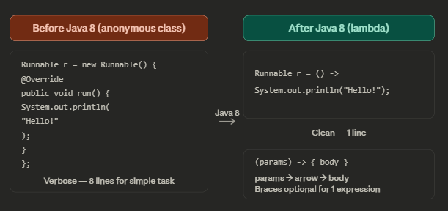
Code :
interface Add{

int addition(int a, int b);
}

public class GFG{

public static void main(String[] args){

// Lambda expression to add two numbers
Add add = (a, b) -> a + b;

int result = add.addition(10, 20);
System.out.println("Sum: " + result);
}
}
interface Add{

int addition(int a, int b);
}

public class GFG{

public static void main(String[] args){

// Lambda expression to add two numbers
Add add = (a, b) -> a + b;

int result = add.addition(10, 20);
System.out.println("Sum: " + result);
}
}

- Parameter List: Parameters for the lambda expression
- Arrow Token (->): Separates the parameter list and the body
- Body: Logic to be executed.

